Schifrin Beckham A-192110696

**CSA-1668 Datawarehousing and Datamining for pattern analysis**

Weka tool Dataset: contact-lenses

Datapreprocessing:

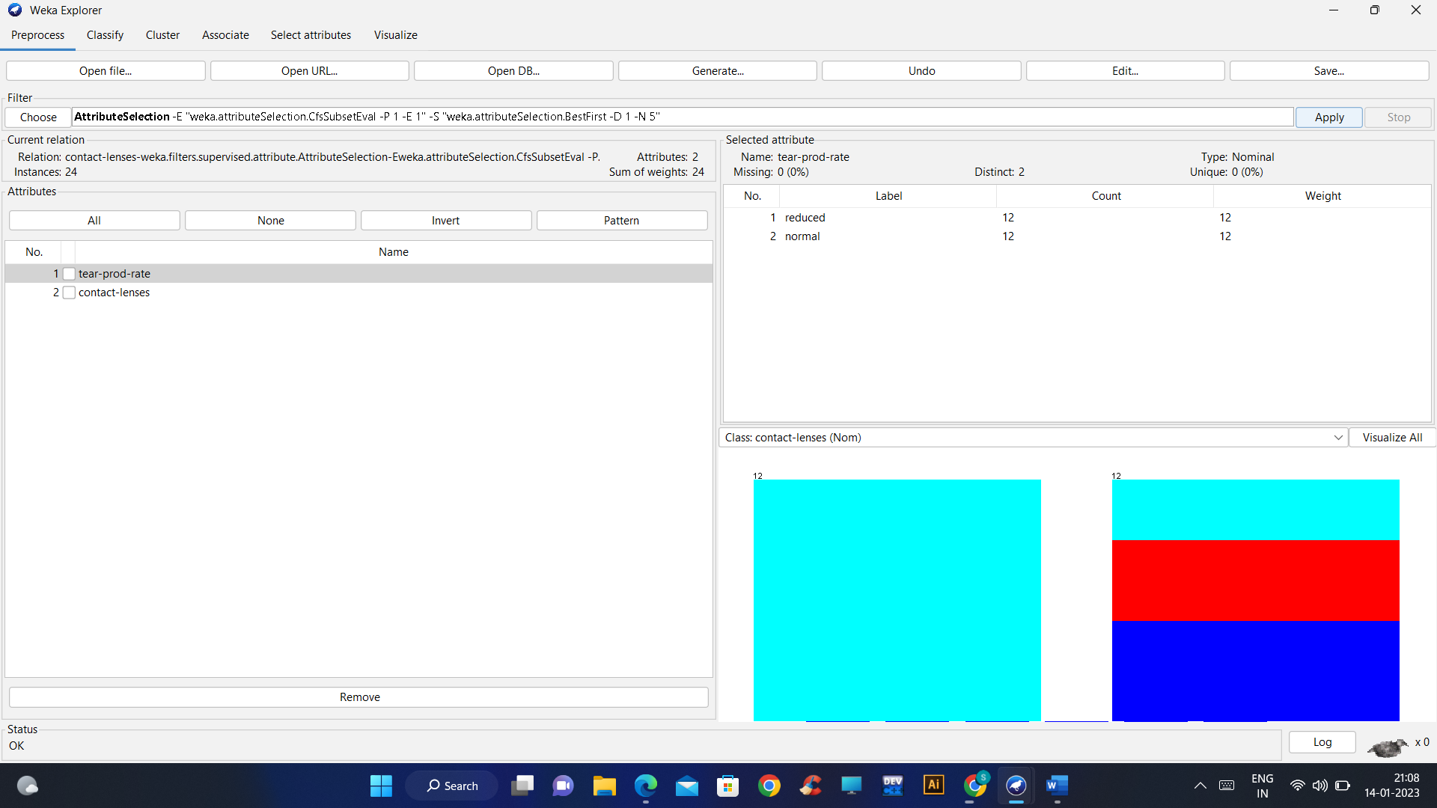

Remove Missing values: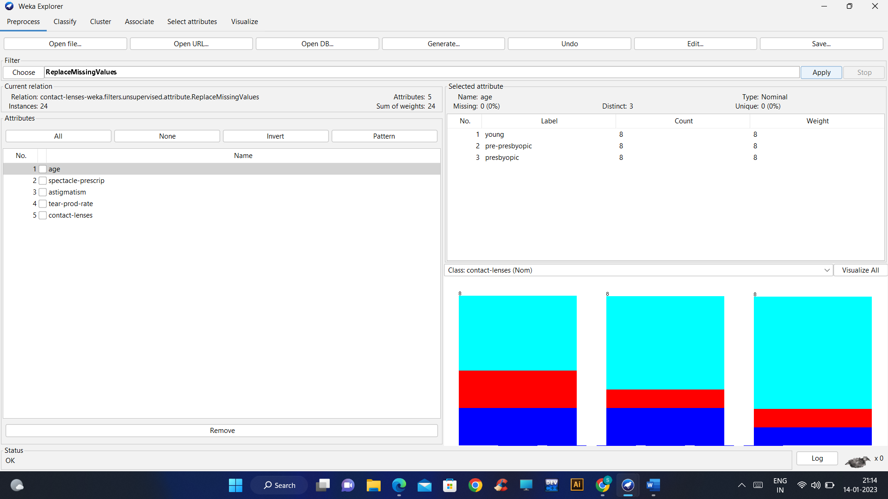

Interquartile range:

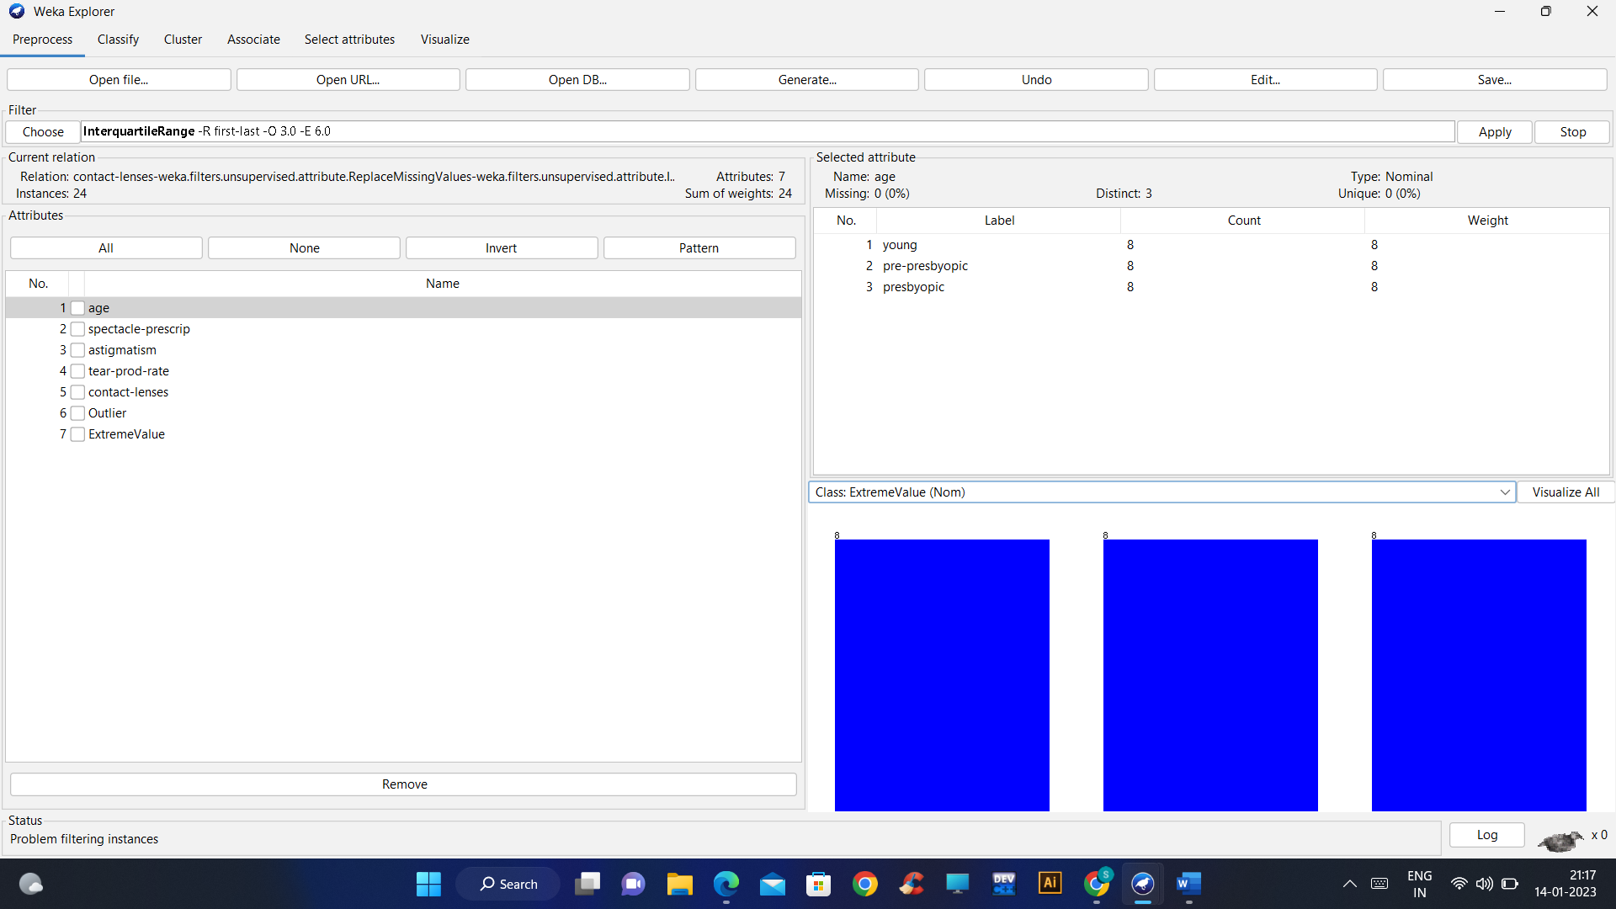

Classification(Bayes):

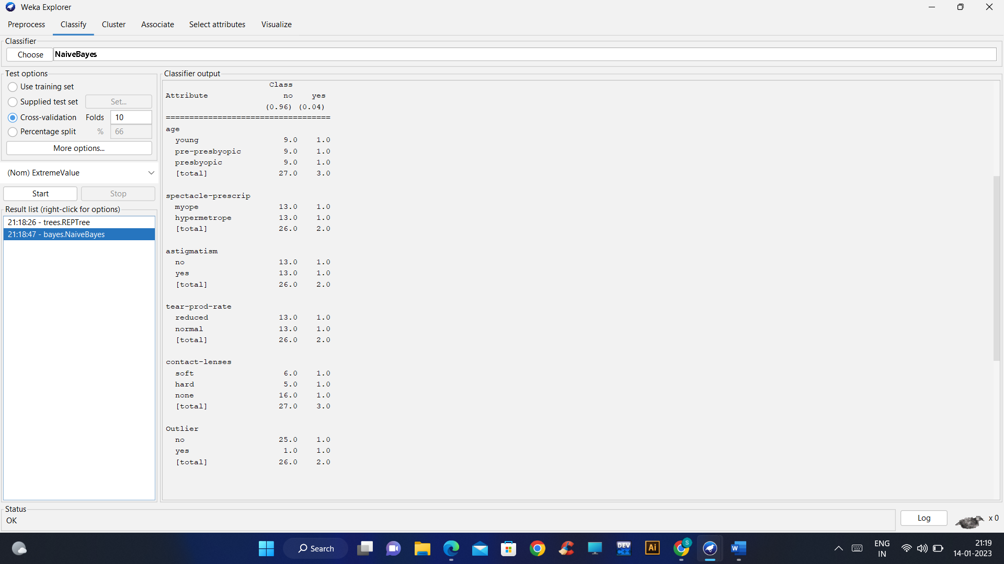

DISCRETIZE:

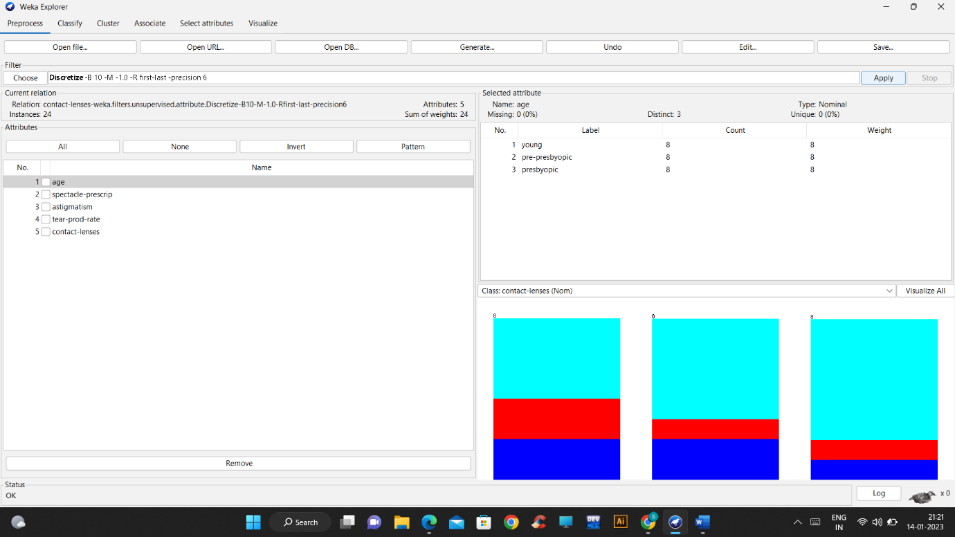

Normalize:

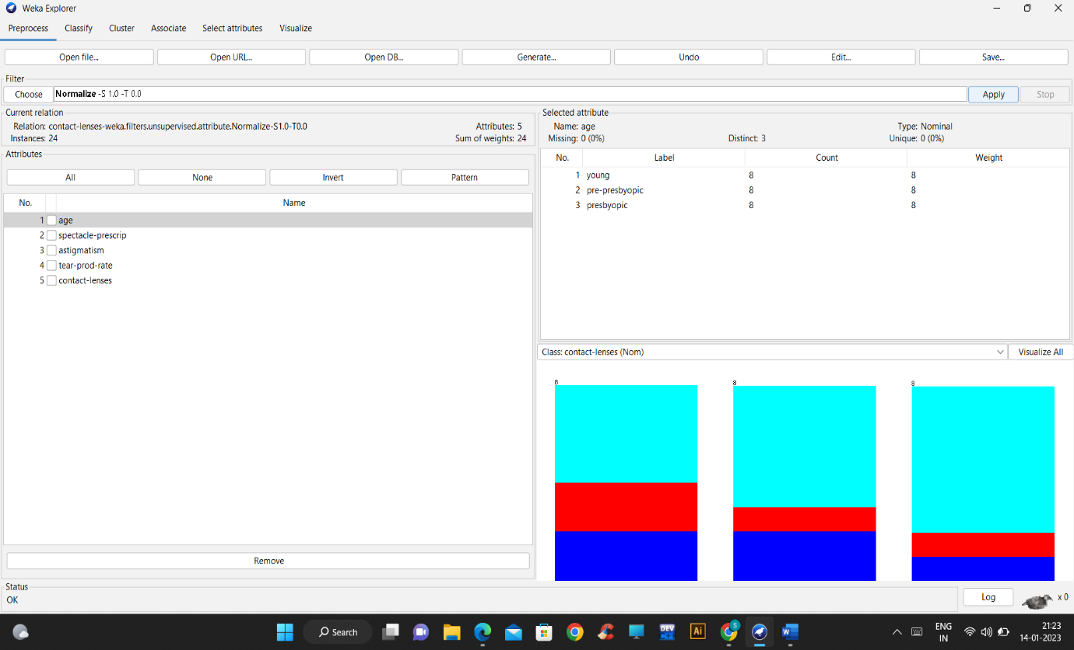

Decision tree classification:

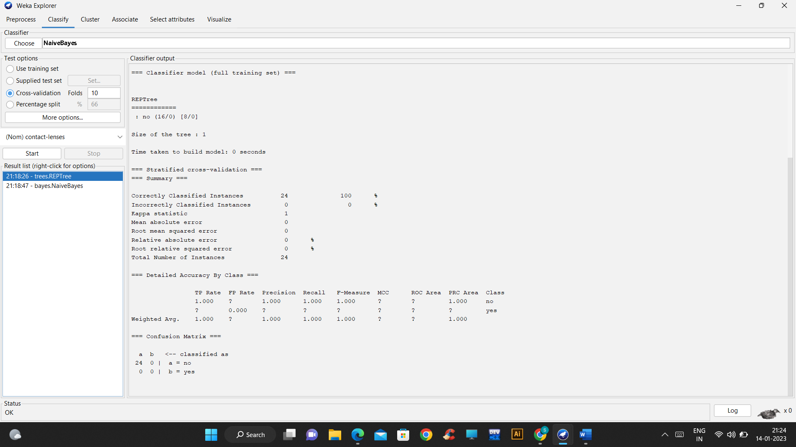

Clustering:

K-means: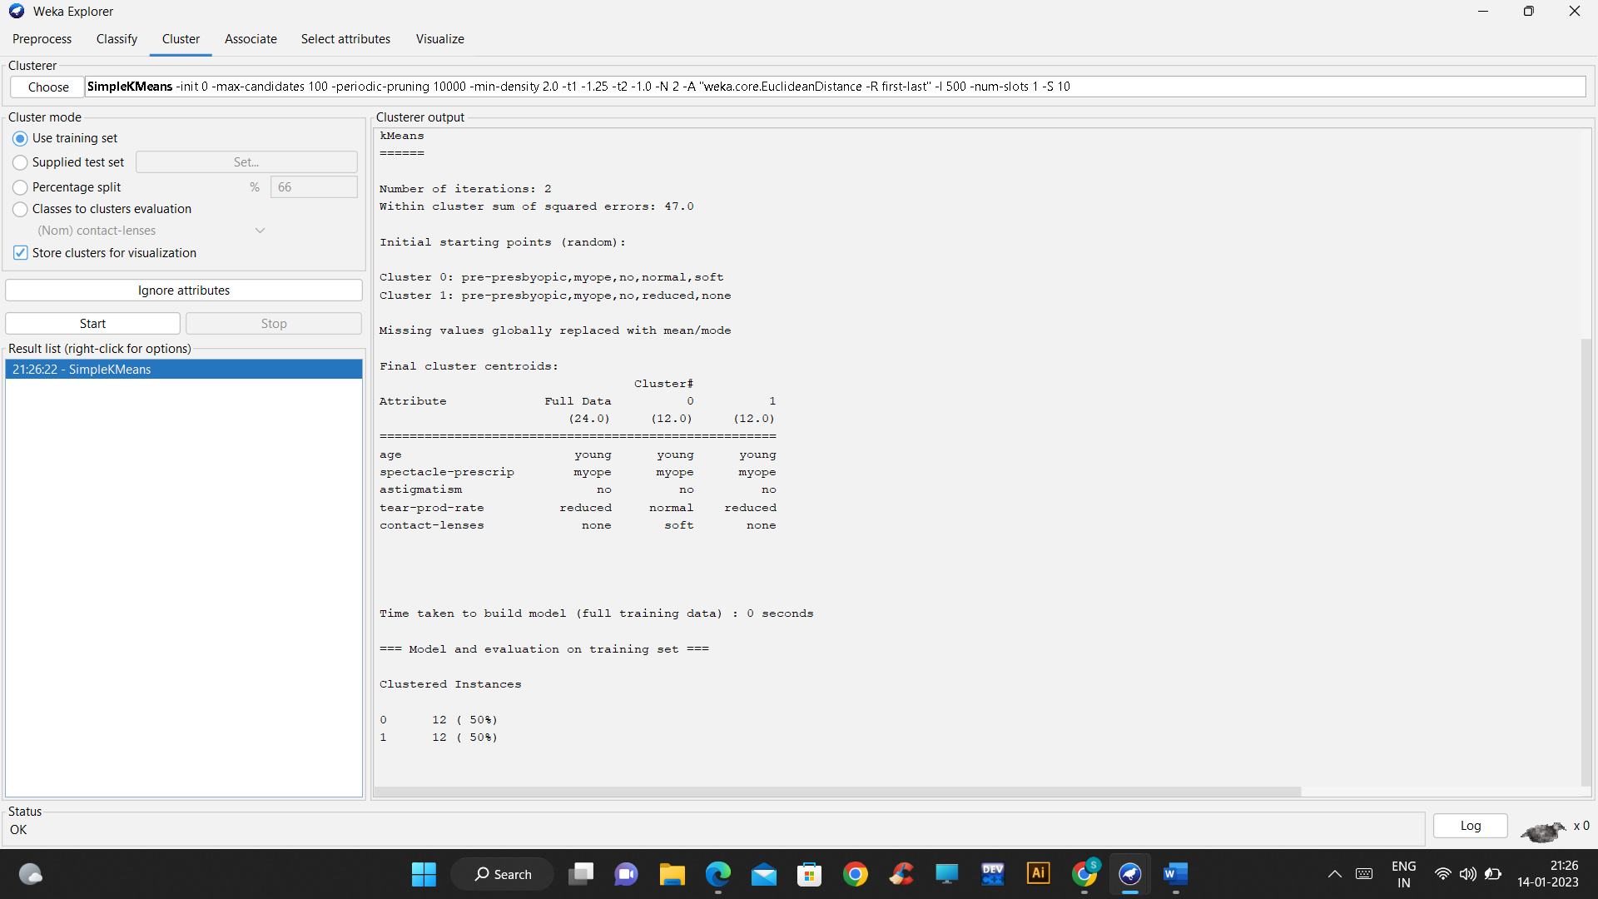

EM :

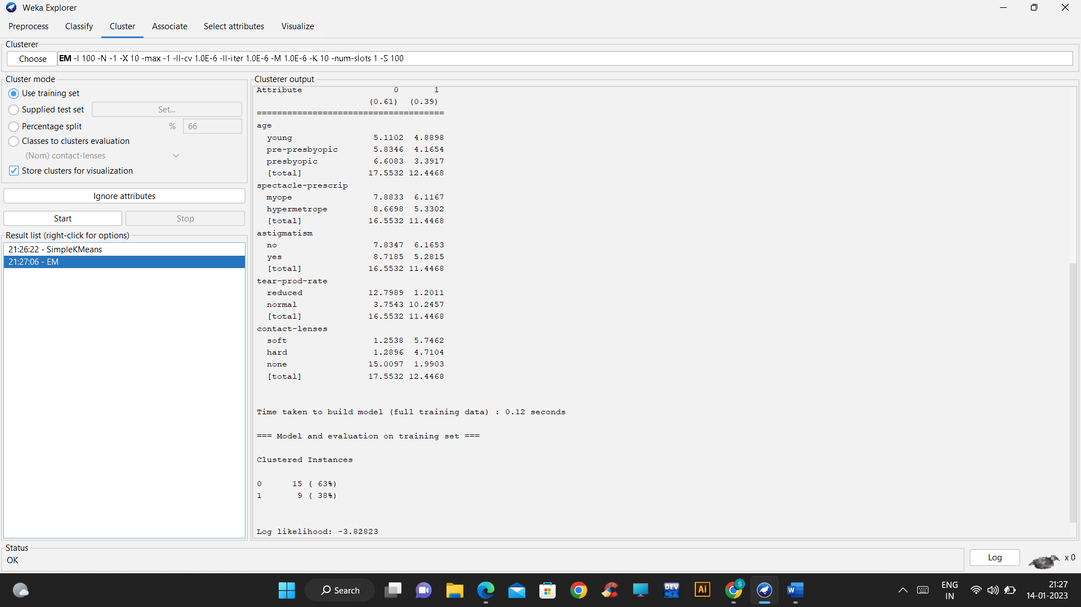

Association Rule:

Apriori:

